SCD Lab 5
(0389)
Task1:
public class task1{
public static void main(String[] args) {
int firstNumber = 5;
int secondNumber = 10;
int sum = firstNumber + secondNumber;

System.out.println(sum);
}
}

Task2:
public class task2 {
public static void main(String[] args) {
int firstValue = 10;
int secondValue = 20;

if (firstValue > secondValue) {
System.out.println(firstValue);
} else {
System.out.println(secondValue);
}
}
}

Task3:
- Class name p is meaningless
- Variable names n, f unclear
- No comments
- Poor spacing
- Hardcoded value (no input)
- No method separation
Improved Version
public class task3 {
public static void main(String[] args) {
int number = 5;
int factorial = 1;

for (int i = 1; i <= number; i++) {
factorial *= i;
}

System.out.println(factorial);
}
}
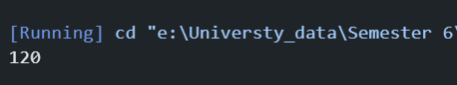
Task4:
Issues:
- Class name A not meaningful
- Multiple statements on one line
- Poor readability
- No spacing
Improved vesion
public class SumExample {
public static void main(String[] args) {
int firstNumber = 10;
int secondNumber = 20;

System.out.println(firstNumber + secondNumber);
}
}

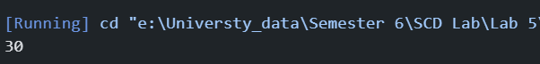
Task5:
/**
* This class calculates factorial of a number.
*/
public class Factorial {

/**
* Method to calculate factorial
* @param number input number
* @return factorial of number
*/
public static int calculateFactorial(int number) {
int factorial = 1;

for (int i = 1; i <= number; i++) {
factorial *= i; // multiply current value
}

return factorial;
}
}

Task6:
public class FactorialLoop {
public static void main(String[] args) {
int result = 1;

for (int i = 1; i <= 10; i++) {
result *= i;
}

System.out.println(result);
}
}

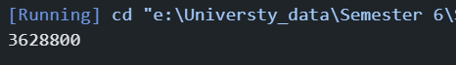
Task7:
public class Multiplication {
public static void main(String[] args) {
int firstNumber = 2;
int secondNumber = 3;

int product = firstNumber * secondNumber;

System.out.println(product);
}
}

Task8:
public class EvenNumbers {
public static void main(String[] args) {
int limit = 10;

// Loop through numbers from 1 to limit
for (int i = 1; i <= limit; i++) {
// Check if number is even
if (i % 2 == 0) {
System.out.println(i);
}
}
}
}
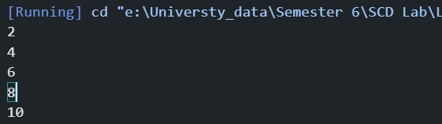
Task9:
public class PrimeCheck {
public static void main(String[] args) {
int number = 7;
boolean isPrime = true;

for (int i = 2; i < number; i++) {
if (number % i == 0) {
isPrime = false;
break;
}
}

if (isPrime) {
System.out.println("Prime");
} else {
System.out.println("Not Prime");
}
}
}

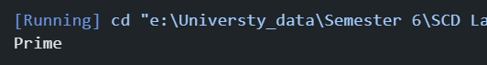

Task10:
Issues:
- Class name z meaningless
- Variable a unclear
- No comments
- Hardcoded loop limit
- No method separation
- Poor readability
Improved Version:
public class FactorialExample {
public static void main(String[] args) {
int number = 5;
int factorial = 1;

for (int i = 1; i <= number; i++) {
factorial *= i;
}

System.out.println(factorial);
}
}

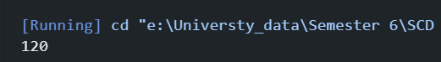
Task11:
public class FactorialProgram {

public static int calculateFactorial(int number) {
int factorial = 1;

for (int i = 1; i <= number; i++) {
factorial *= i;
}

return factorial;
}

public static void main(String[] args) {
int number = 5;
int result = calculateFactorial(number);

System.out.println("Factorial: " + result);
}
}

Task12:
public class PrimeProgram {

public static boolean isPrime(int number) {
if (number <= 1) return false;

for (int i = 2; i < number; i++) {
if (number % i == 0) {
return false;
}
}

return true;
}

public static void main(String[] args) {
int number = 7;

if (isPrime(number)) {
System.out.println("Prime");
} else {
System.out.println("Not Prime");
}
}
}

Task13:
public class StringReverse {
public static void main(String[] args) {
String originalString = "Hello";
String reversedString = "";

for (int i = originalString.length() - 1; i >= 0; i--) {
reversedString += originalString.charAt(i);
}

System.out.println("Reversed: " + reversedString);
}
}

